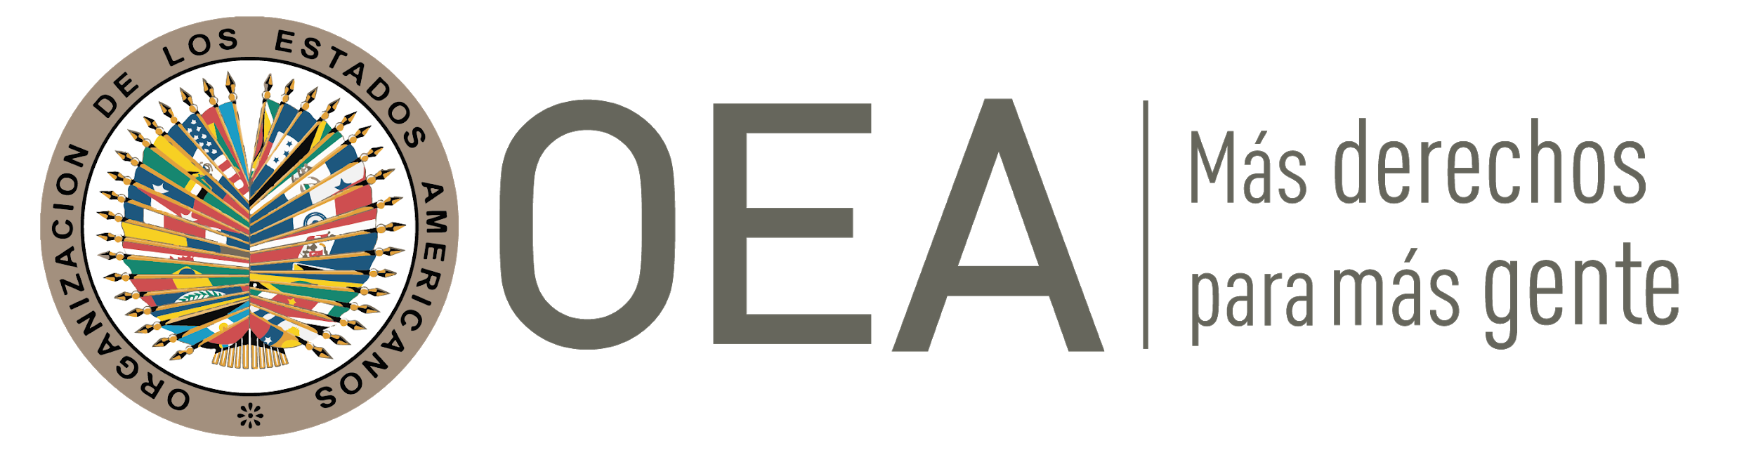**COLLABORATION SKILLS**

**RESOURCES**

1.-The Power of Teacher Collaboration

<https://www.teachingchannel.com/blog/teacher-collaboration>

2-Ten Strategies to Build Student Collaboration in Classroom

<https://gsehd.gwu.edu/articles/10-strategies-build-student-collaboration-classroom>

3-Deeper Learning: A Collaborative Classroom Is Key

<https://www.edutopia.org/blog/deeper-learning-collaboration-key-rebecca-alber>

# 4. Video: The Deep Dive: ABC Nightline - IDEO Shopping Cart (2009)

<https://www.youtube.com/watch?v=M66ZU2PCIcM>

5. Collaborating Learning

<https://teaching.cornell.edu/teaching-resources/engaging-students/collaborative-learning>

6. 20 Collaborative Learning Tips and Strategies for Teachers (image)

<https://www.teachthought.com/pedagogy/20-collaborative-learning-tips-and-strategies/>

# 7. Seven Online Collaborative Learning Strategies to Keep Students Engaged While At Home

<https://www.eduflow.com/blog/online-collaborative-learning-strategies-to-keep-students-engaged-while-at-home>

8. Fundamental Collaboration Skills

<https://snacknation.com/blog/virtual-team-building/>

9. Digital Resources to Enhance Collaboration Skills

<https://www.thebalancecareers.com/collaboration-skills-with-examples-2059686#:~:text=Collaboration%20skills%20enable%20you%20to,and%20how%20to%20develop%20them>