**OAS KM Group**

**Thursday, September 19, 2019**

**Participants:**

Denise Goolsarran, CEDOGR/DO, Facilitator

Karen Bozicovich, DPS, Co-facilitator

Enrica De Pasquale, CEDOGR, DPE

Mauricio Fonnegra, DOITS

Gaby Hernandez, DHR

Mariana Herrera, SARE

Betty Rodriguez, CEDOGR, DO

Joining us for the first time:

Andrea Escobedo, CEDOGR, DIA

Miryam Hazan, SARE

Cho Jeonga, CEDOGR, DO

Lili M. Romero-DeSimone, EO/SAF

Vivian Sanchez, CEDOGR, DPE

Alin Valenzuela, SEDI/DHDEE

**Objective: To discuss the Group’ understanding of knowledge management, shared definitions and to determine the best way to communicate about Knowledge Management to the Organization; and the role of the OAS KM Group.**

1. **Group Discussion:** The group discussed its understanding of knowledge and what Knowledge Management means in the context of the OAS based on the slides presented.

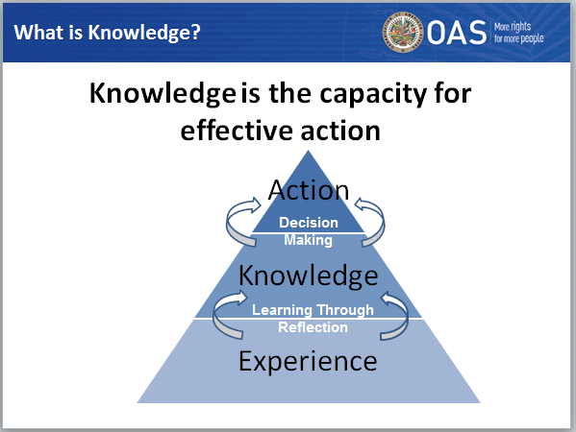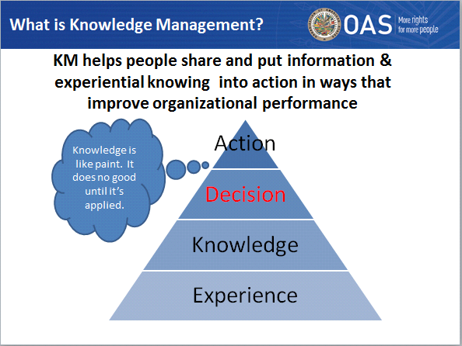

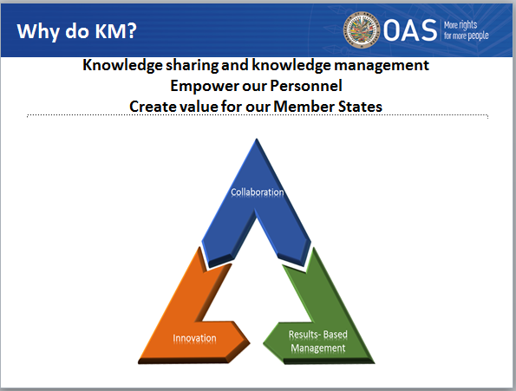

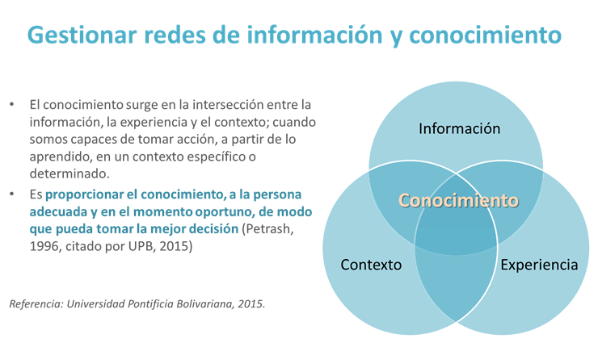

The group added the following:

Knowledge is at the intersection of information, experience and context. (Alin) See diagram above.

It helps to achieve Organizational objectives. (Karen)

Knowledge is what the organization produces. It is an organizational asset. (Lili)

It is about getting the right knowledge, to the right people at the right moment. (The right knowledge has to do with classification of knowledge - Karen).

**ACTION ITEM**: Each person will work writing a - what’s in it for me – WIFM statement to be shared at the next meeting.

1. **Knowledge Management in the context of the OAS:** Our approach to knowledge management at the GS/OAS is informed by the challenges of modernization identified in diagnostic studies including Deloitte and Touche (2004) and the Strategic Management Plan for Modernization of the OAS (Murray Report 2014). Both of these studies identified challenges for the OAS including a workforce fragmented into separate work units (silo mentality), limited collaboration and coordination within and between Secretariats and pillars.

In response the CEDOGR/DO has developed a transformation strategy to address these challenges and the Department of Human Resources has developed a complementary culture change strategy. The Core Organizational Competencies defined with the input of Secretaries and Directors include: Leading with Knowledge and Conviction, Results-Based Management, Collaboration, and Innovation. Our knowledge management efforts support the Organization’s effort to respond to the challenges of modernization to transit towards a more collaborative, innovative, results-oriented, and learning organization with the capacity to respond in a more agile manner to meet the challenges of the 21st Century by capitalizing on its cumulative knowledge to strengthen its capacity for greater impact in its member states.

1. **Communicating about the importance of Knowledge Management**: There was a discussion about communicating the importance of KM to support our work and enable us to work in ways that are more effective and efficient.

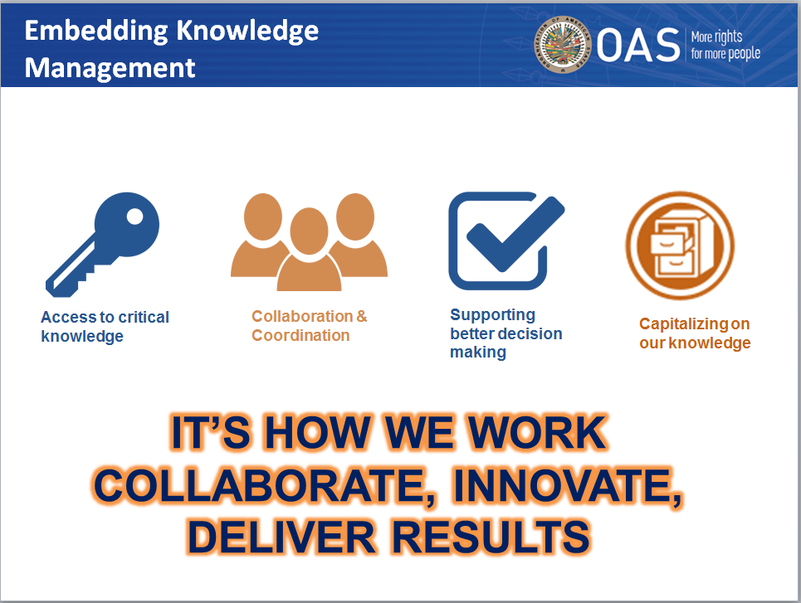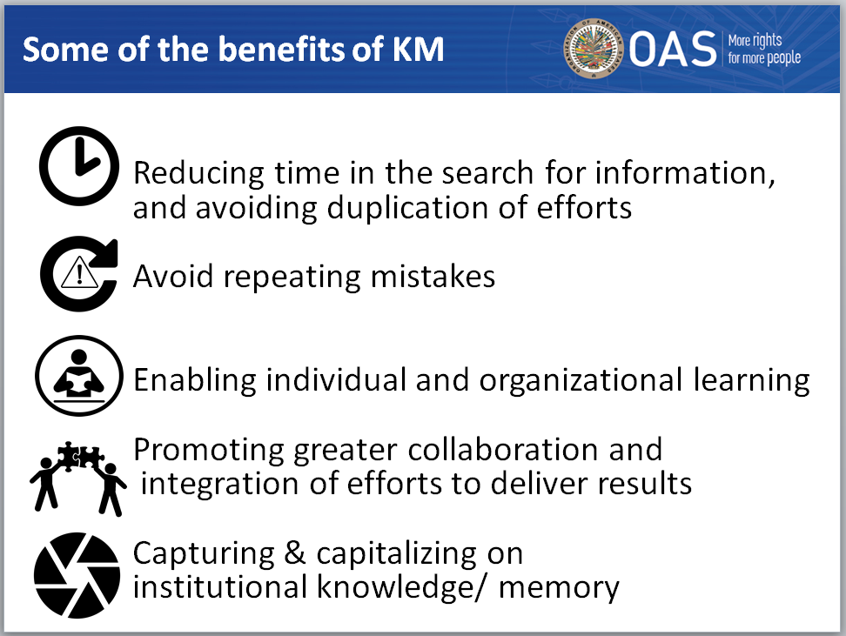

There was also a discussion on how understanding our organizational culture and understanding our audience is critical for informing our communication efforts. It was recognized that to develop a communication strategy it was important to identify possible areas of resistance, understand it and determine what the communication message should be.

**ACTION ITEMS**: For the group to work on together (Working session to be defined)

1. Understand possible areas of resistance determine how to frame the message so that it would not be experienced as threatening
2. Define the different audiences and the messages for the various audiences
3. Prepare a presentation that could be shared with the different Secretariats and Departments
4. **Creating incentives for knowledge management**:

The group discussed the need to incentivize knowledge sharing behaviors and a recommendation was made that an addition be made to include a question about volunteering and participation in committees in the revised Performance Evaluation (PES).

For example: Do you participate in any volunteer activities in the OAS or in any committees? List.

Recognition could also be given those individuals participate and volunteer extensively recognizing their contributions in those committees.

**ACTION ITEM**: Gaby will communicate the idea to DHR and we will follow up with DHR.

1. **Working with Organizational Partners**:

CEDOGR/DO has as one of its Strategic Objectives: “Promoting and consolidating organizational development.” Working in partnership with the different areas of the Organization CEDOGR/DO -to this end DO, has been facilitating an OAS Knowledge Management Group, establishing alliances with leaders in KM in other organizations, who serve as a sounding board to guide our KM initiatives; and is working in partnership with different areas to identify challenges that could be addressed by improving knowledge management and will work to support the implementation of pilot initiatives to learn on a small scale, and to inform our efforts at developing a KM framework.

1. **Role of the OAS KM Group**:

There was a brief exchange about the role of the OAS KM Group serving as champions of KM in their areas. Members of the OAS KM Group would accompany and support presentations to their areas on KM and serve as KM contact points. Members of the OAS KM Group could also identify areas in which improved knowledge management could support the delivery of Organizational objectives and could serve as leads for pilots in their areas.

There was some discussion about expanding the group to facilitate better gender representation.

**ACTION ITEMS:** For the group to work on together (Next working session)

1. Group to agree on a name to be used in future communications organization-wide. There was one proposal for discussion: “T4KM”
2. Group to work on the content for the communication on the OASKM Group
3. Betty to consult with CIM and develop an approach for outreach to facilitate better gender representation (List of names of people who were trained on KM and participated in developing the original KM projects to be provided and Betty to do follow-up).
4. Develop an elevator speech on what KM means for us at the OAS.
5. **On-going and potential pilots:**

Karen Bozicovich - is facilitating a KM pilot with DPS (she previously presented to the group on this)

Lili Romero – is facilitating an AMS Advisory Group (Lili shared with the group on this pilot initiative)

Alin Valenzuela – is exploring the possibility of setting up a Learning Group for her area

Miryam Hazan – has convened a Group to discuss migration

All of these are potential KM initiatives responding to a need and supporting the development of an Organizational objective. The role of CEDOGR / DO is to work with partners to support their implementation.

**ACTION ITEM:** Learning from these pilots will be shared with the OAS KM Group to facilitate learning

1. **Other:** Mariana mentioned that she had a specific KM challenge in relation to the strategic planning exercise and Lili suggested that perhaps knowledge sharing between the CIDH and the areas involved in preparing for the next strategic plan could enable us to learn from the CIDH’s Strategic Planning process.
2. **Guest presenter:** I have identified a possible guest presenter who can lead us to explore the stories we tell about knowledge sharing, problem solving, and collaboration in the Organization.
3. **Next steps:**
4. Group to define how it wants to be called – so that we could have a communication about the OAS KM Group
5. The next meeting of the OAS KM Group will be to work on the communication about the OAS KM group, starting with the WIFM statements.
6. Use the OAS Facebook page to post pictures and updates about the OAS KM Group (a volunteer needed) and the group will define the message about for the Facebook page.
7. **Acknowledgements:** Thank you all for making the meeting a very productive one! Thank you for your time, for the many ideas shared and for your energy. We would like to recognize the contribution of Cho, who developed several of the slides in the PPT.
8. **Next meeting:** Possibly the 2nd week in October. We will confirm the date.